Instructions to use install and use the Telugu typing software (IT3)

1. Copy the folder Telugu Translation into your laptop
2. Unzip the folder, you will find Pothana2000 font file, Translation Tool (Firefox or IE document), Telugu mapping table and supporting files
3. Copy the Pothana2000 font file into the **fonts folder in Control panel**
4. Click on the Language Translation Tool (Firefox or IE document) file
5. **The tool will open up in the browser**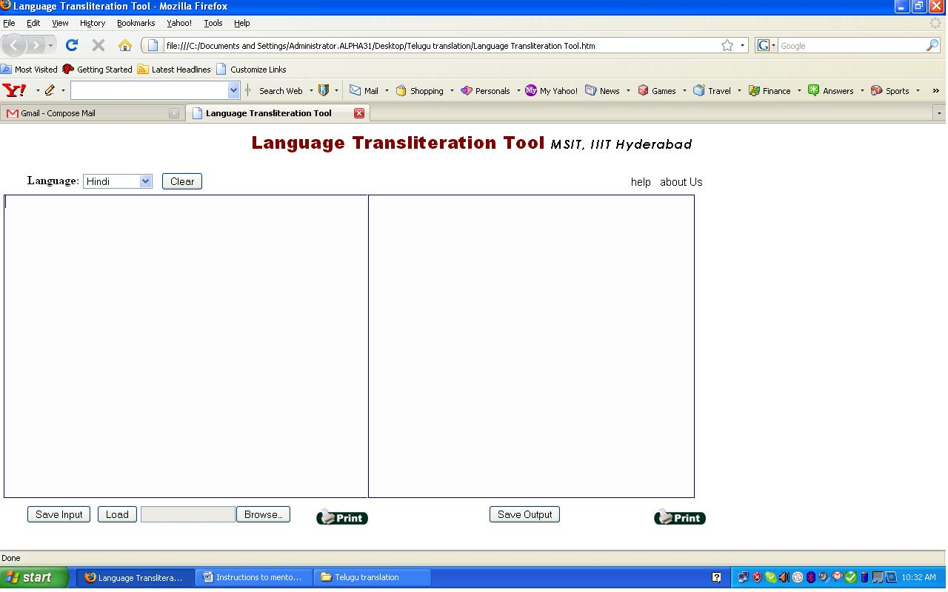
6. **Select the Language**

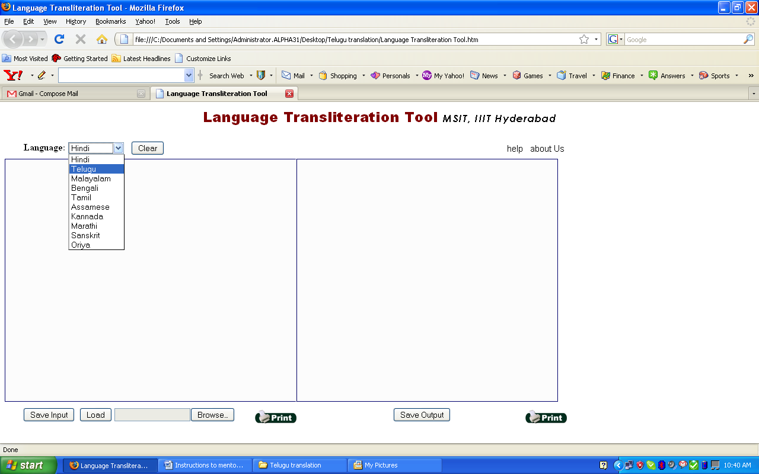

1. **Start typing in the left side window in English, For eg: amma for అమ్మ and you can see the Telugu output in the right side window.**

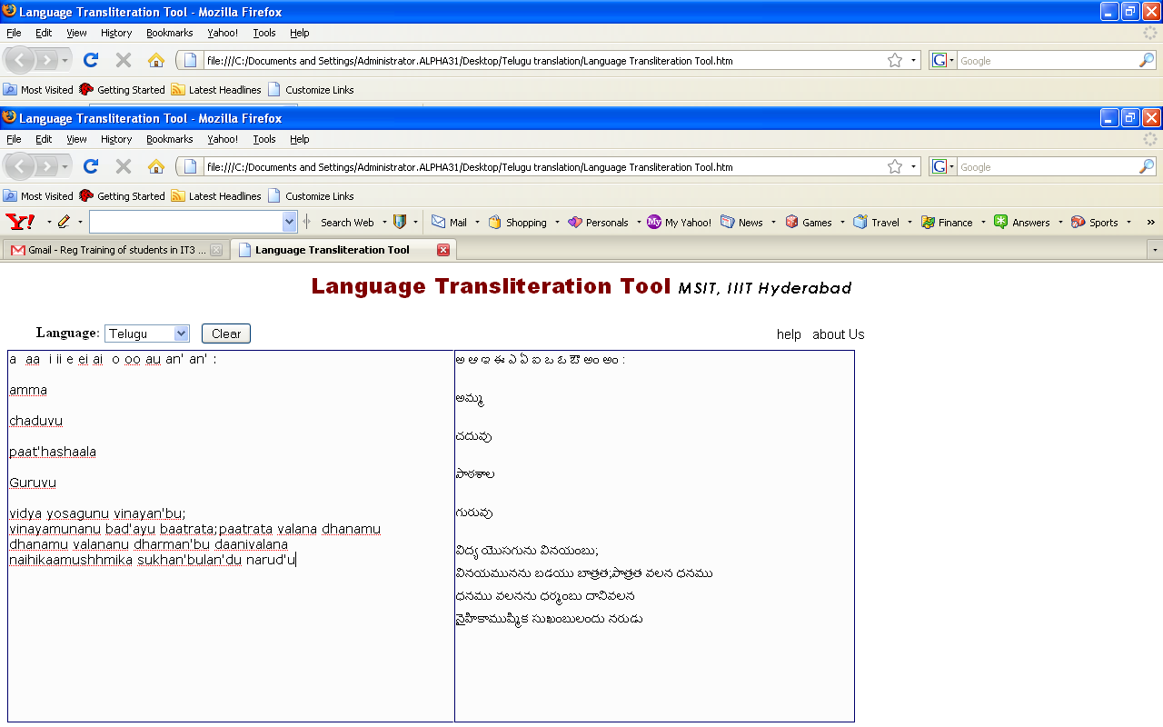**8. Mapping table, provided for your reference in the Telugu Translation software folder, refer to the table.**

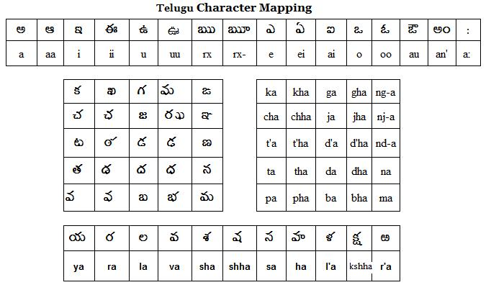

1. **After typing the desired text select the Telugu text from the right side window**

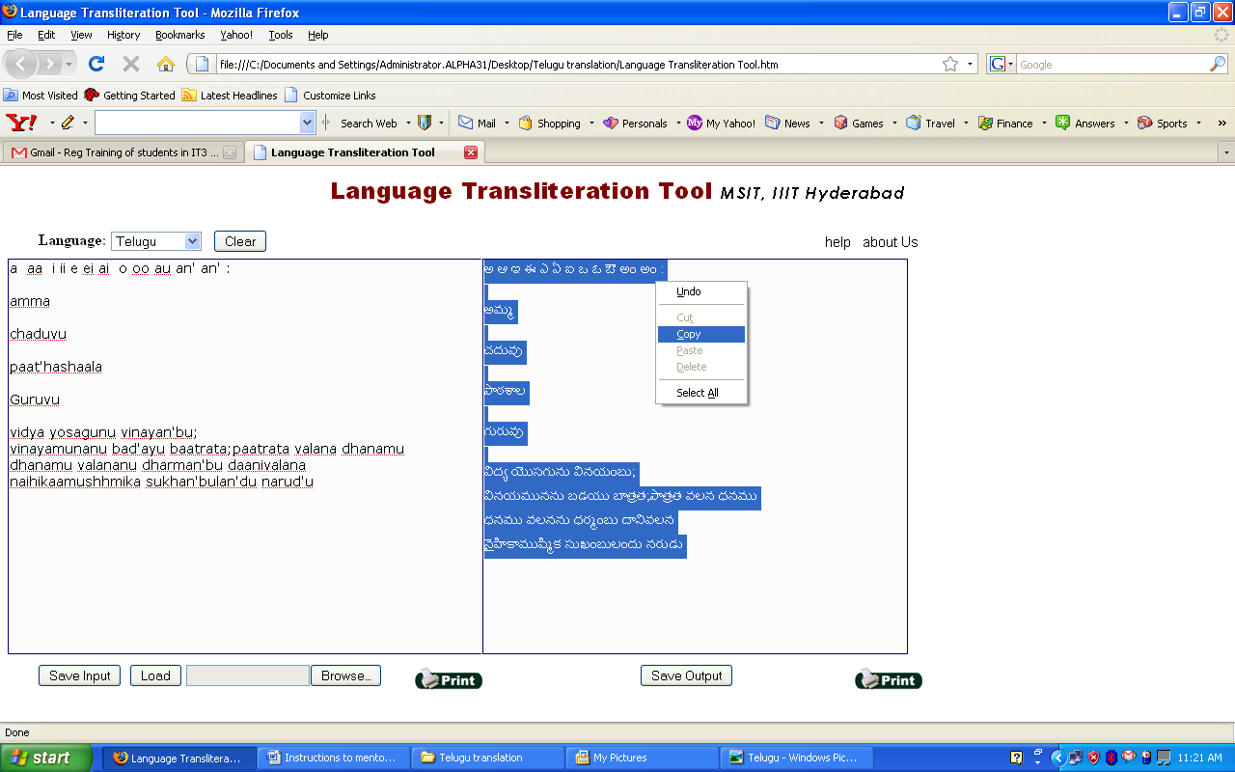

1. **Copy the text into the word document and save the file.**

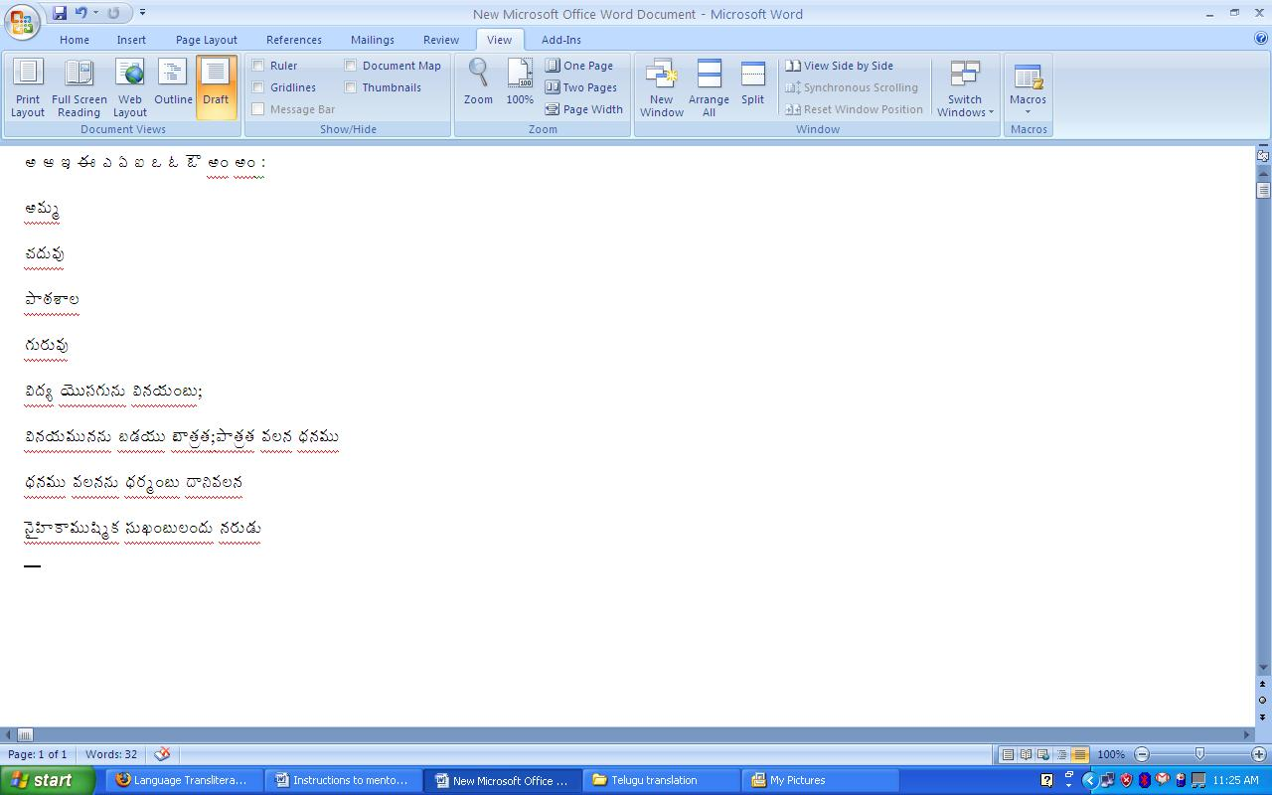

1. **You can use this tool as per the instructions of your Telugu mentor and submit the assignments.**